Types of NICs
# Source: AI Source: Provided by: [Data Path: Persons Table -> ID Column: 1, Name_En Column: Motasem Essam] -> From: [ChatGPT] on [12/18/2025]
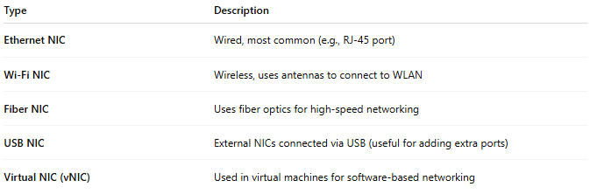
Type | Description
Ethernet NIC | Wired, most common (e.g., RJ-45 port)
Wi-Fi NIC | Wireless, uses antennas to connect to WLAN
Fiber NIC | Uses fiber optics for high-speed networking
USB NIC | External NICs connected via USB (useful for adding extra ports)
Virtual NIC (vNIC) | Used in virtual machines for software-based networking

